Abstract—Put here a short (1 paragraph) abstract of your project, summarizing the system analyzed, the analysis methodology, your findings, implications of the findings, and proposed countermeasures (if any).
<Put the Title of Your Analysis Project Here>
July 31, 2026
First A. Author, Second B. Author, Jr., and Third C. Author
Department of Electrical and Computer Engineering
University of British Columbia
Vancouver, Canada
<list e-mail addresses of the authors>

INTRODUCTION
THE introduction section should (1) motivate your analysis, i.e., explain why security analysis of such systems is important, (2) summarize the related work (i.e., who else performed similar analyses or analyzed similar systems), (3) summarize the analysis methodology, (4) summarize the results of your analysis, (5) summarize the implications of the findings (i.e., the “So what?”), (6) summarize the principles of designing secure systems that have been violated by the system designers, owners, users, or operators, and (7) summarize the countermeasures you propose to reduce the risks associated with the discovered vulnerabilities.
This section should be one page or less.

Analyzed System
This section should describe those elements of the system that are important for the purpose of describing the performed analysis later in the report.

Related Work
This section should explain who else has analyzed same or similar system, how they performed the analysis, and what their findings are.

Analysis Methodology
This section should explain how the system was analyzed. Focus on the most important for the reader elements of your analysis and explain them in great detail. This section should take about 50% of your report!

Results
This section should describe the results of the analysis. Remember to keep the description of the analysis and the description of its findings in separate sections.

Discussion
Explain what your findings mean. That is, why are they significant?

Explain which principles of designing secure systems have been violated by the system designers, owners, users, or operators

Discuss the limitations of your analysis.

Also, suggest how the system should have been designed differently to avoid the vulnerabilities your found.

This section should be about one page.

Conclusion
This section should summarize the report in 1-2 paragraphs. Although a conclusion may review the main points of the report, do not replicate the abstract as the conclusion. A conclusion might elaborate on the importance of the work or suggest applications and extensions.

Helpful Hints

Figures and Tables
Position figures and tables at the top and bottom of each column. Large figures and tables may span both columns. Place figure captions below the figures; place table titles above the tables. If your figure has two parts, include the labels “(a)” and “(b)” as part of the artwork. Please verify that the figures and tables you mention in the text actually exist. Please do not include captions as part of the figures. Do not put captions in “text boxes” linked to the figures. Do not put borders around the outside of your figures. Use the abbreviation “Fig.” even at the beginning of a sentence. Do not abbreviate “Table.” Tables are numbered with Roman numerals.
Figure axis labels are often a source of confusion. Use words rather than symbols. As an example, write the quantity “Magnetization,” or “Magnetization M,” not just “M.” Put units in parentheses. Do not label axes only with units. As in Fig. 1, for example, write “Magnetization (A/m)” or “Magnetization (Am⁻¹),” not just “A/m.” Do not label axes with a ratio of quantities and units. For example, write “Temperature (K),” not “Temperature/K.”
Multipliers can be especially confusing. Write “Magnetization (kA/m)” or “Magnetization (10³ A/m).” Do not write “Magnetization (A/m) × 1000” because the reader would not know whether the top axis label in Fig. 1 meant 16000 A/m or 0.016 A/m. Figure labels should be legible, approximately 8 to 12 point type.

References
Number citations consecutively in square brackets [1]. The sentence punctuation follows the brackets [2]. Multiple references [2], [3] are each numbered with separate brackets [1]–[3]. When citing a section in a book, please give the relevant page numbers [2]. In sentences, refer simply to the reference number, as in [3]. Do not use “Ref. [3]” or “reference [3]” except at the beginning of a sentence: “Reference [3] shows ... .” Please do not use automatic endnotes in Word, rather, type the reference list at the end of the paper using the “References” style.
Number footnotes separately in superscripts (Insert | Footnote). Place the actual footnote at the bottom of the column in which it is cited; do not put footnotes in the reference list (endnotes). Use letters for table footnotes (see Table I).
Please note that the references at the end of this document are in the preferred referencing style. Give all authors’ names; do not use “et al.” unless there are six authors or more. Use a space after authors’ initials. Papers that have not been published should be cited as “unpublished” [4]. Papers that have been accepted for publication, but not yet specified for an issue should be cited as “to be published” [5]. Papers that have been submitted for publication should be cited as “submitted for publication” [6]. Please give affiliations and addresses for private communications [7].
Capitalize only the first word in a paper title, except for proper nouns and element symbols. For papers published in translation journals, please give the English citation first, followed by the original foreign-language citation [8].
TABLE I
Units for Magnetic Properties
Symbol | Quantity | Conversion from Gaussian and  CGS EMU to SI ª
Φ | magnetic flux | 1 Mx → 10⁻⁸ Wb = 10⁻⁸ V·s
B | magnetic flux density,  magnetic induction | 1 G → 10⁻⁴ T = 10⁻⁴ Wb/m²
H | magnetic field strength | 1 Oe → 10³/(4π) A/m
m | magnetic moment | 1 erg/G = 1 emu  → 10⁻³ A·m² = 10⁻³ J/T
M | magnetization | 1 erg/(G·cm³) = 1 emu/cm³  → 10³ A/m
4πM | magnetization | 1 G → 10³/(4π) A/m
σ | specific magnetization | 1 erg/(G·g) = 1 emu/g → 1 A·m²/kg
j | magnetic dipole  moment | 1 erg/G = 1 emu  → 4π × 10⁻¹⁰ Wb·m
J | magnetic polarization | 1 erg/(G·cm³) = 1 emu/cm³  → 4π × 10⁻⁴ T
χ, κ | susceptibility | 1 → 4π
χ_{ρ} | mass susceptibility | 1 cm³/g → 4π × 10⁻³ m³/kg
μ | permeability | 1 → 4π × 10⁻⁷ H/m  = 4π × 10⁻⁷ Wb/(A·m)
μ_{r} | relative permeability | μ → μ_{r}
w, W | energy density | 1 erg/cm³ → 10⁻¹ J/m³
N, D | demagnetizing factor | 1 → 1/(4π)
This is an example of how tables should be placed in the report.

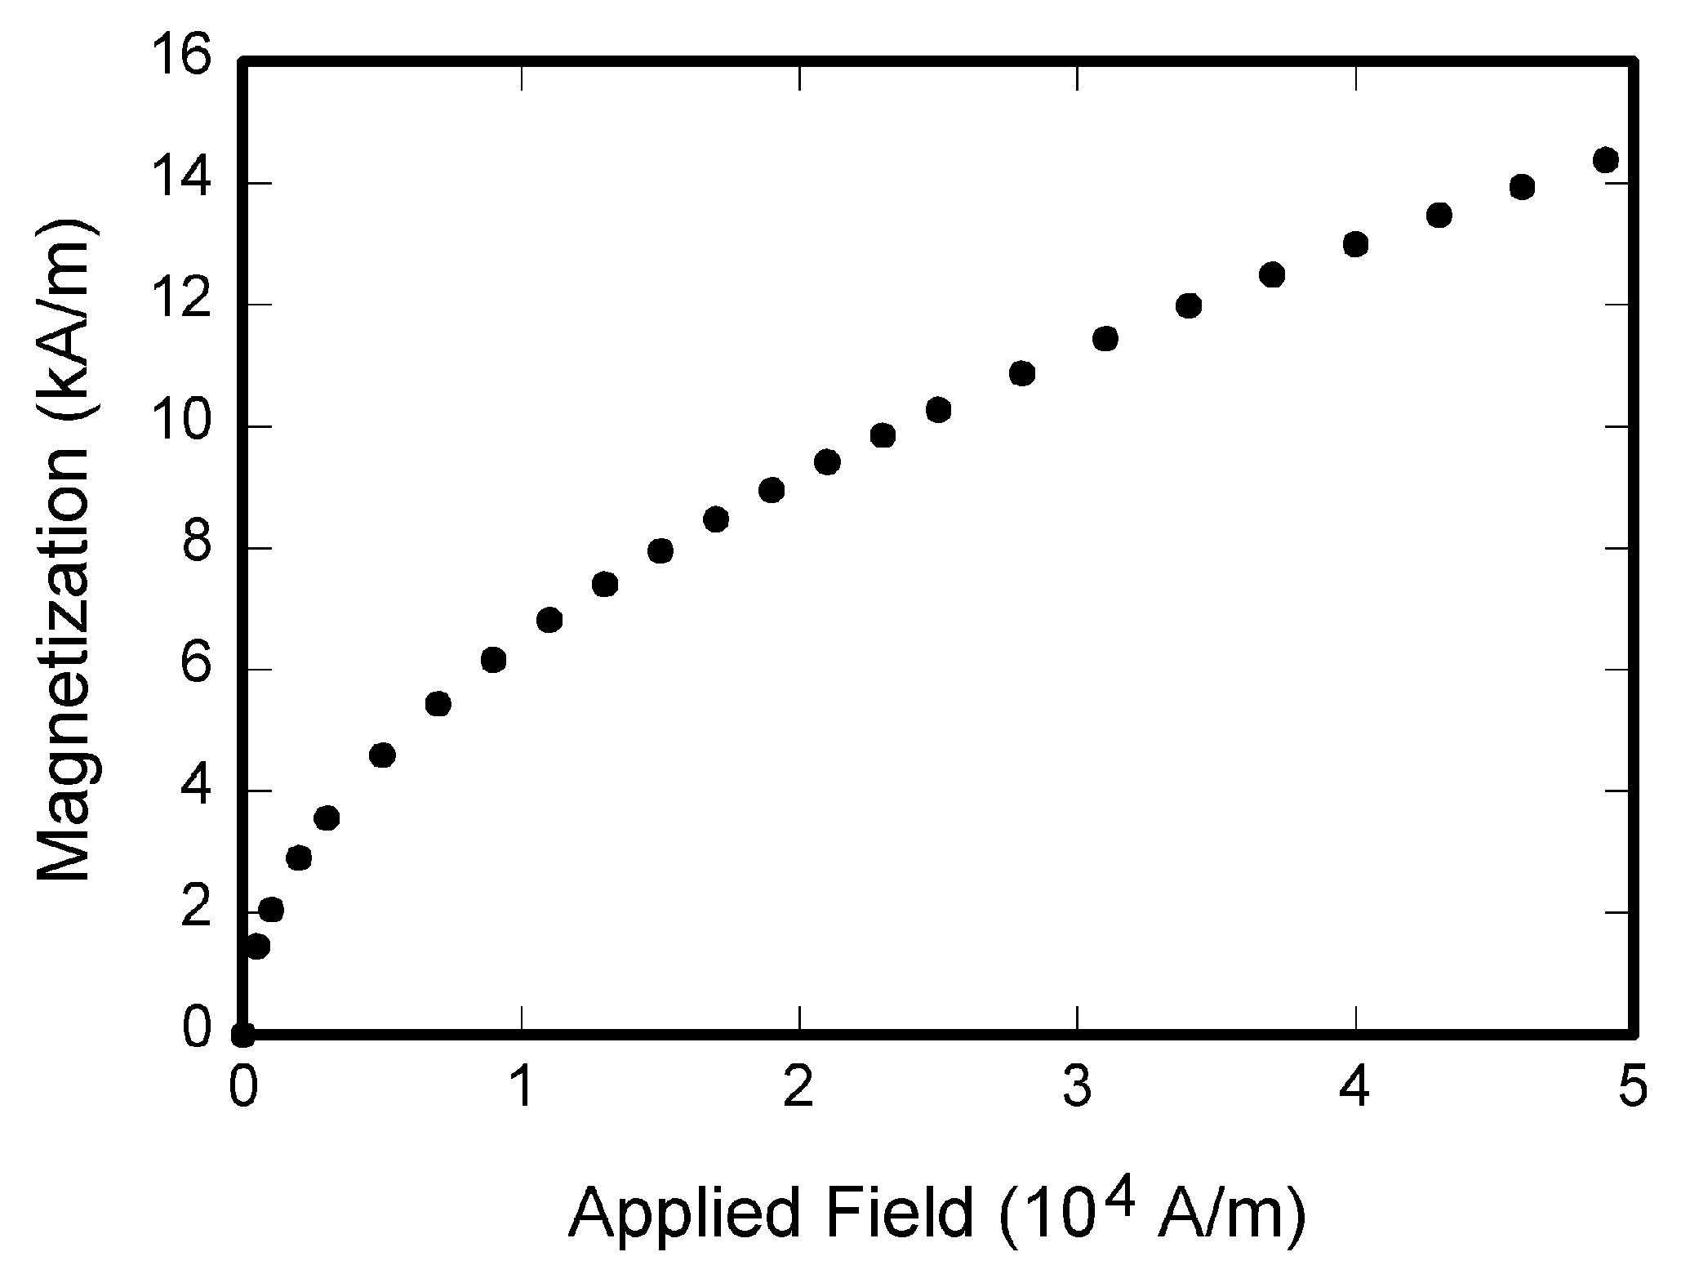
Fig. 1. This is an example of how graphs should be placed in the report.

Abbreviations and Acronyms
Define abbreviations and acronyms the first time they are used in the text, even after they have already been defined in the abstract. Abbreviations such as IEEE, SI, ac, and dc do not have to be defined. Abbreviations that incorporate periods should not have spaces: write “C.N.R.S.,” not “C. N. R. S.” Do not use abbreviations in the title unless they are unavoidable (for example, “IEEE” in the title of this article).

Equations
Number equations consecutively with equation numbers in parentheses flush with the right margin, as in (1). First use the equation editor to create the equation. Then select the “Equation” markup style. Press the tab key and write the equation number in parentheses. To make your equations more compact, you may use the solidus ( / ), the exp function, or appropriate exponents. Use parentheses to avoid ambiguities in denominators. Punctuate equations when they are part of a sentence, as in

$\begin{aligned}\int{ F(r,ϕ)} \text{dr} dϕ=[{σr}_{2} (2μ_{0})] \\ ⋅ \int{ \text{exp}}(−λ|z_{j}−z_{i}| ) λ^{−1} J_{1}(λ r_{2}) J_{0}(λ r_{i}) dλ \text{.}\end{aligned}$ (1)

Be sure that the symbols in your equation have been defined before the equation appears or immediately following. Italicize symbols (T might refer to temperature, but T is the unit tesla). Refer to “(1),” not “Eq. (1)” or “equation (1),” except at the beginning of a sentence: “Equation (1) is ... .”

Other Recommendations
Use one space after periods and colons. Hyphenate complex modifiers: “zero-field-cooled magnetization.” Avoid dangling participles, such as, “Using (1), the potential was calculated.” [It is not clear who or what used (1).] Write instead, “The potential was calculated by using (1),” or “Using (1), we calculated the potential.”
Use a zero before decimal points: “0.25,” not “.25.” Use “cm³,” not “cc.” Indicate sample dimensions as “0.1 cm × 0.2 cm,” not “0.1 × 0.2 cm².” The abbreviation for “seconds” is “s,” not “sec.” Do not mix complete spellings and abbreviations of units: use “Wb/m²” or “webers per square meter,” not “webers/m².” When expressing a range of values, write “7 to 9” or “7-9,” not “7~9.”
A parenthetical statement at the end of a sentence is punctuated outside of the closing parenthesis (like this). (A parenthetical sentence is punctuated within the parentheses.) In American English, periods and commas are within quotation marks, like “this period.” Other punctuation is “outside”! Avoid contractions; for example, write “do not” instead of “don’t.” The serial comma is preferred: “A, B, and C” instead of “A, B and C.”
If you wish, you may write in the first person singular or plural and use the active voice (“I observed that ...” or “We observed that ...” instead of “It was observed that ...”). Remember to check spelling. If your native language is not English, please get a native English-speaking colleague to carefully proofread your paper.
A general IEEE style guide and an Information for Authors are both available at http://www.ieee.org/web/publications/authors/transjnl/index.html
Appendix
Appendixes, if needed, appear before the acknowledgment.
Acknowledgment
The preferred spelling of the word “acknowledgment” in American English is without an “e” after the “g.” Use the singular heading even if you have many acknowledgments. Avoid expressions such as “One of us (S.B.A.) would like to thank ... .” Instead, write “F. A. Author thanks ... .” Sponsor and financial support acknowledgments are placed in the unnumbered footnote on the first page, not here.
References
- G. O. Young, “Synthetic structure of industrial plastics (Book style with paper title and editor),” in Plastics, 2nd ed. vol. 3, J. Peters, Ed. New York: McGraw-Hill, 1964, pp. 15–64.
- W.-K. Chen, Linear Networks and Systems (Book style). Belmont, CA: Wadsworth, 1993, pp. 123–135.
- H. Poor, An Introduction to Signal Detection and Estimation. New York: Springer-Verlag, 1985, ch. 4.
- B. Smith, “An approach to graphs of linear forms (Unpublished work style),” unpublished.
- E. H. Miller, “A note on reflector arrays (Periodical style—Accepted for publication),” IEEE Trans. Antennas Propagat., to be published.
- J. Wang, “Fundamentals of erbium-doped fiber amplifiers arrays (Periodical style—Submitted for publication),” IEEE J. Quantum Electron., submitted for publication.
- C. J. Kaufman, Rocky Mountain Research Lab., Boulder, CO, private communication, May 1995.
- Y. Yorozu, M. Hirano, K. Oka, and Y. Tagawa, “Electron spectroscopy studies on magneto-optical media and plastic substrate interfaces (Translation Journals style),” IEEE Transl. J. Magn.Jpn., vol. 2, Aug. 1987, pp. 740–741 [Dig. 9th Annu. Conf. Magnetics Japan, 1982, p. 301].
- M. Young, The Techincal Writers Handbook. Mill Valley, CA: University Science, 1989.
- J. U. Duncombe, “Infrared navigation—Part I: An assessment of feasibility (Periodical style),” IEEE Trans. Electron Devices, vol. ED-11, pp. 34–39, Jan. 1959.
- S. Chen, B. Mulgrew, and P. M. Grant, “A clustering technique for digital communications channel equalization using radial basis function networks,” IEEE Trans. Neural Networks, vol. 4, pp. 570–578, Jul. 1993.
- R. W. Lucky, “Automatic equalization for digital communication,” Bell Syst. Tech. J., vol. 44, no. 4, pp. 547–588, Apr. 1965.
- S. P. Bingulac, “On the compatibility of adaptive controllers (Published Conference Proceedings style),” in Proc. 4th Annu. Allerton Conf. Circuits and Systems Theory, New York, 1994, pp. 8–16.
- G. R. Faulhaber, “Design of service systems with priority reservation,” in Conf. Rec. 1995 IEEE Int. Conf. Communications, pp. 3–8.
- W. D. Doyle, “Magnetization reversal in films with biaxial anisotropy,” in 1987 Proc. INTERMAG Conf., pp. 2.2-1–2.2-6.
- G. W. Juette and L. E. Zeffanella, “Radio noise currents n short sections on bundle conductors (Presented Conference Paper style),” presented at the IEEE Summer power Meeting, Dallas, TX, Jun. 22–27, 1990, Paper 90 SM 690-0 PWRS.
- J. G. Kreifeldt, “An analysis of surface-detected EMG as an amplitude-modulated noise,” presented at the 1989 Int. Conf. Medicine and Biological Engineering, Chicago, IL.
- J. Williams, “Narrow-band analyzer (Thesis or Dissertation style),” Ph.D. dissertation, Dept. Elect. Eng., Harvard Univ., Cambridge, MA, 1993.
- N. Kawasaki, “Parametric study of thermal and chemical nonequilibrium nozzle flow,” M.S. thesis, Dept. Electron. Eng., Osaka Univ., Osaka, Japan, 1993.
- J. P. Wilkinson, “Nonlinear resonant circuit devices (Patent style),” U.S. Patent 3 624 12, July 16, 1990.
- IEEE Criteria for Class IE Electric Systems (Standards style), IEEE Standard 308, 1969.
- Letter Symbols for Quantities, ANSI Standard Y10.5-1968.
- R. E. Haskell and C. T. Case, “Transient signal propagation in lossless isotropic plasmas (Report style),” USAF Cambridge Res. Lab., Cambridge, MA Rep. ARCRL-66-234 (II), 1994, vol. 2.
- E. E. Reber, R. L. Michell, and C. J. Carter, “Oxygen absorption in the Earth’s atmosphere,” Aerospace Corp., Los Angeles, CA, Tech. Rep. TR-0200 (420-46)-3, Nov. 1988.
- (Handbook style) Transmission Systems for Communications, 3rd ed., Western Electric Co., Winston-Salem, NC, 1985, pp. 44–60.
- Motorola Semiconductor Data Manual, Motorola Semiconductor Products Inc., Phoenix, AZ, 1989.
- (Basic Book/Monograph Online Sources) J. K. Author. (year, month, day). Title (edition) [Type of medium]. Volume (issue). Available: http://www.(URL)
- J. Jones. (1991, May 10). Networks (2nd ed.) [Online]. Available: http://www.atm.com
- (Journal Online Sources style) K. Author. (year, month). Title. Journal [Type of medium]. Volume(issue), paging if given. Available: http://www.(URL)
- R. J. Vidmar. (1992, August). On the use of atmospheric plasmas as electromagnetic reflectors. IEEE Trans. Plasma Sci. [Online]. 21(3). pp. 876–880. Available: http://www.halcyon.com/pub/journals/21ps03-vidmar

 
It is recommended that footnotes be avoided (except for the unnumbered footnote with the receipt date on the first page). Instead, try to integrate the footnote information into the text.

